CSA1509-Cloud computing and Big Data Analytics
Name : yuvan shankar
Reg.no: 192511072

EXP 15 : Create a Snapshot of a VM and Test it by loading the Previous Version/Cloned VM
Aim:
To Create a Snapshot of a VM and Test it by loading the Previous Version/Cloned VM.

Steps:
- Download VMware software and install it as Type-2 Hypervisor.
- Download Ubuntu or tiny os as ISO image file.
- In VMware workstation → Create new VM
- Do the configuration based on given conditions.
  - Add extra Hard disk and allocate Storage to it.
- Create VM
- Go to VM→ Click on Snapshot→Take snapshot.
- We can create n number of Snapshots and can be view through snapshot Manager.
- Launch the VM.

Implementation:
- Download and open VMware software.
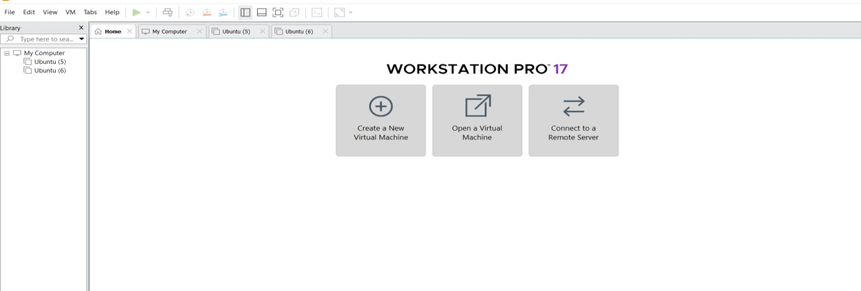

Create a new VM

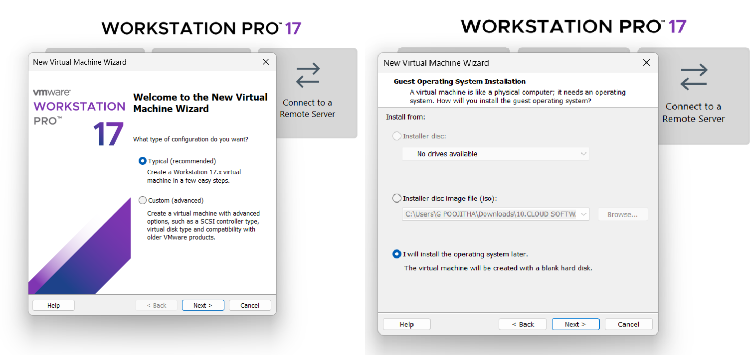
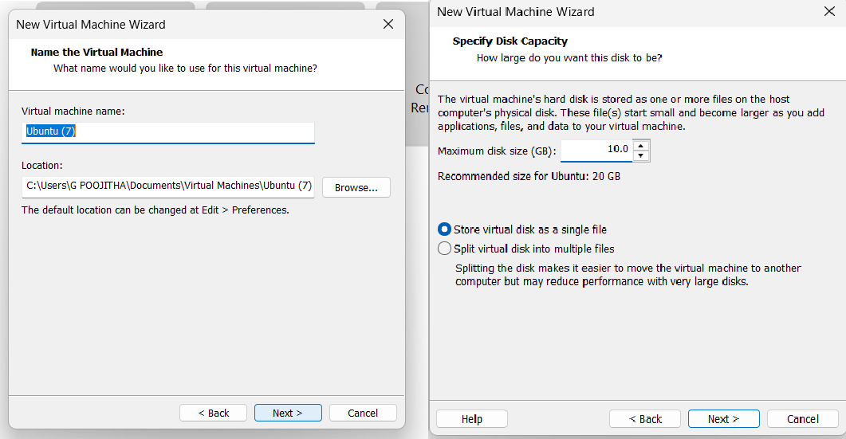

Name it anything→click on next→Adjust the size of disk → change the option to first and then click on next.
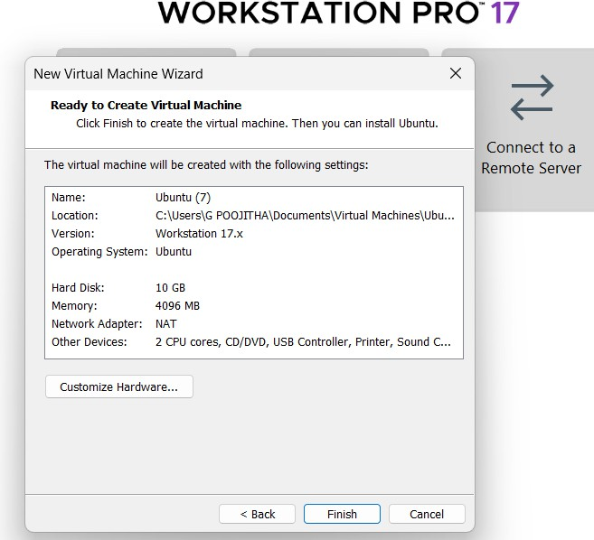 Click on Finish to Launch .

VM is created
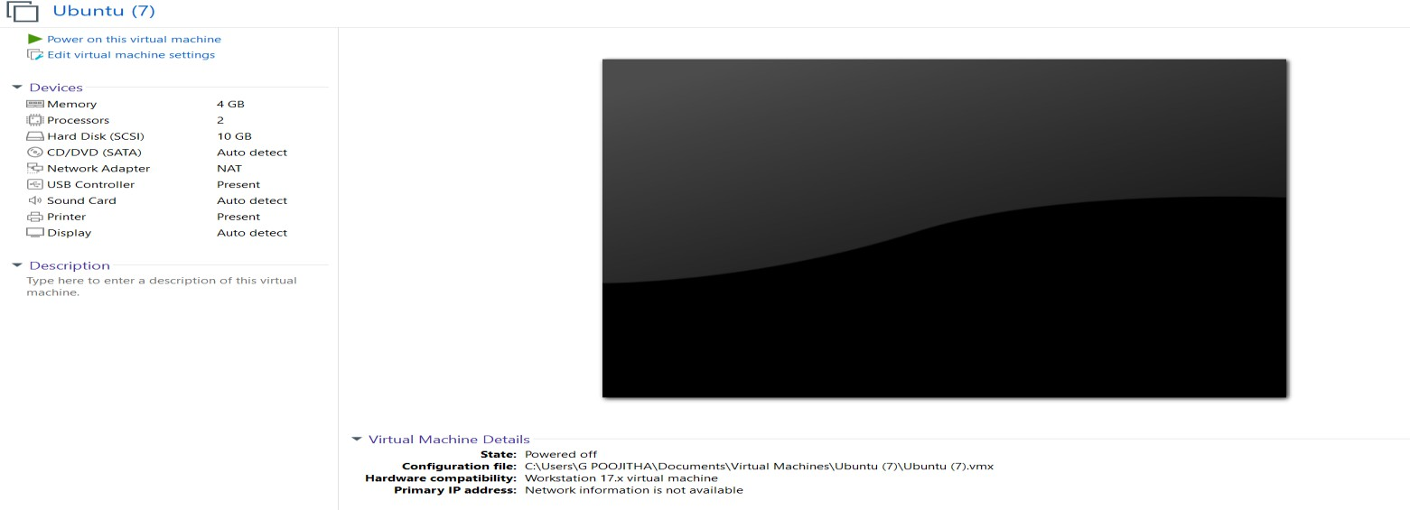

Create Snapshot
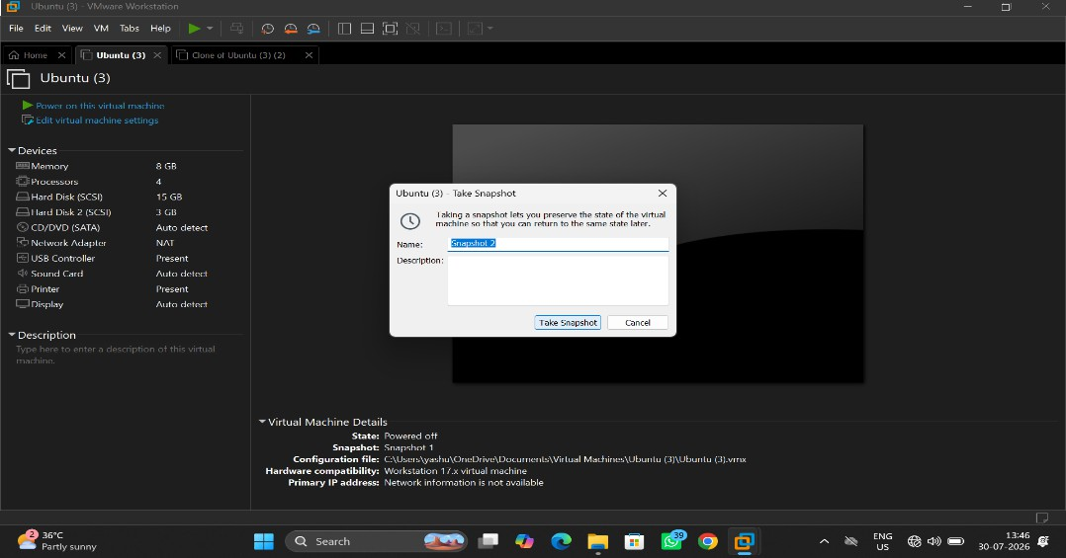

View Snapshot
